Upper Missouri River Water Quality Report 2018-2019: Lewis and Clark and Cascade Counties, MT

Prepared for:

Alan Shaw
Pete Peterson, Sherry Meador, Bailey Sory and Pat Hunter
Project Managers/Co-Chairs/Board

Upper Missouri Watershed Alliance UMOWA
Wolf Creek, Montana
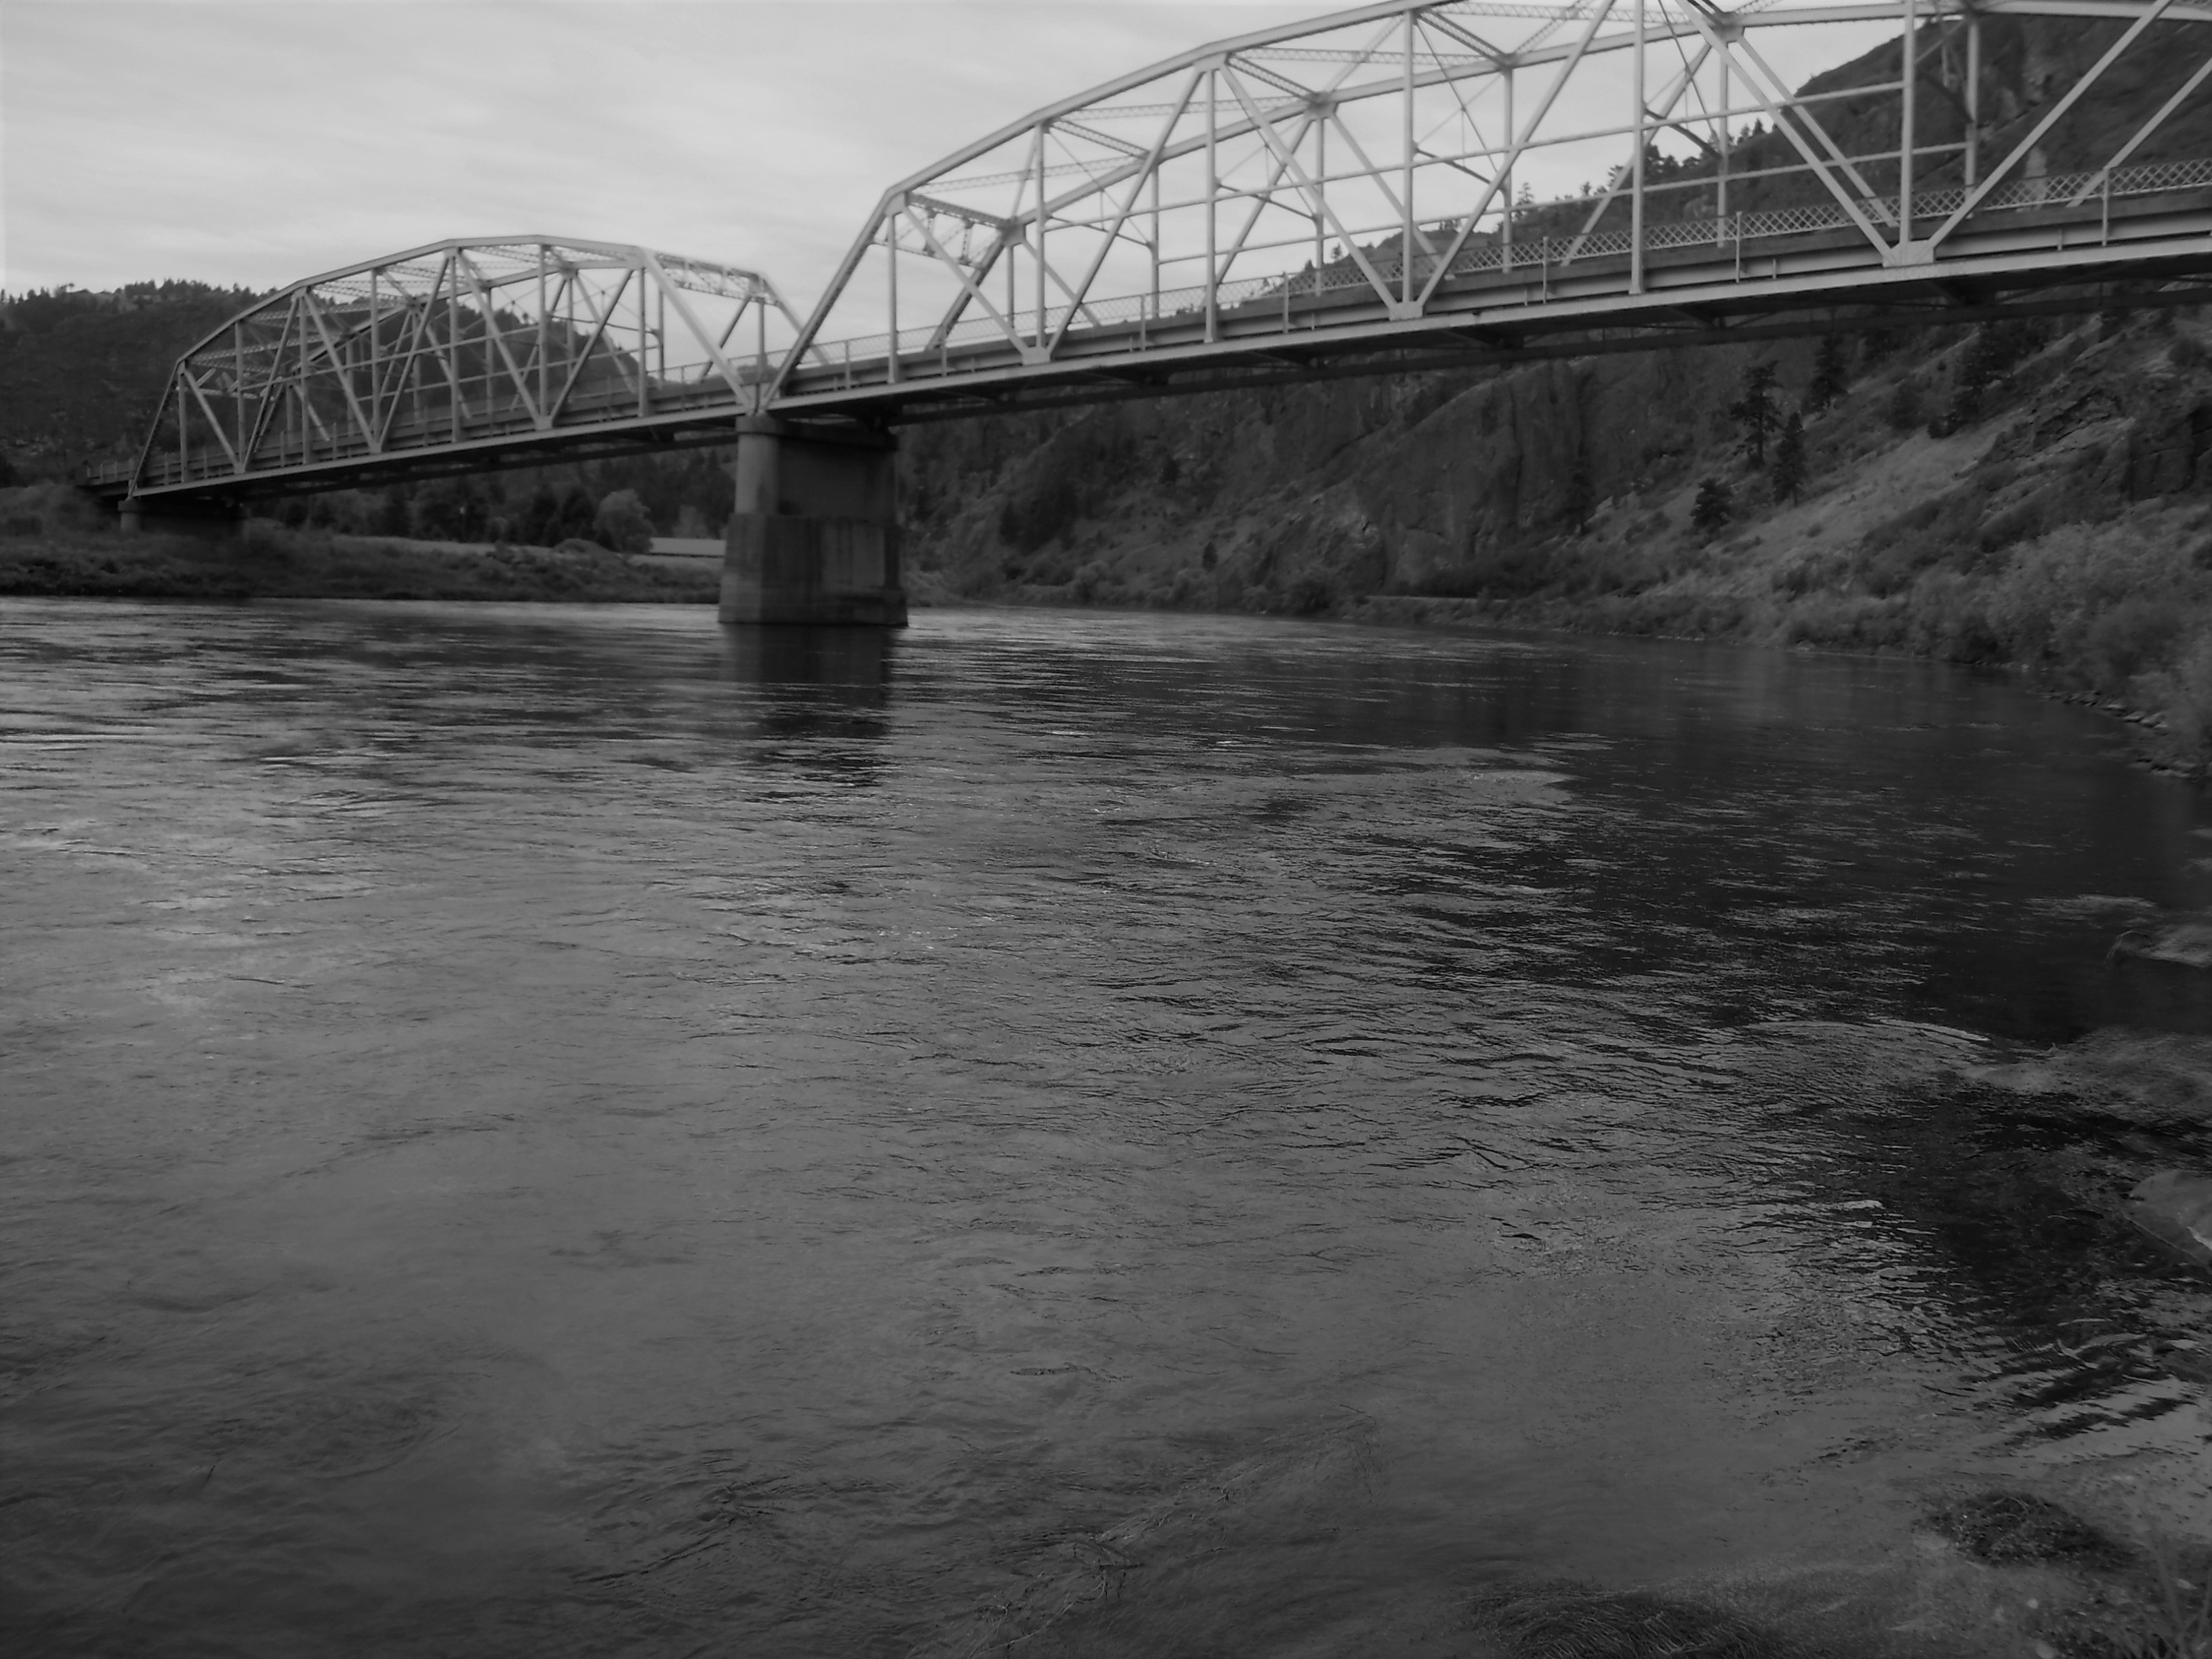

Prepared by:
Dave Stagliano, Montana Biological Survey
April 2020



Table of Contents
Executive Summary 3
1.0 Introduction 4
2.0 Methods 5
2.1 Sample Site Selection 5
2.2 Sample Timing 6
2.3 Water Sampling Methods 6
2.4 Quality Assurance – Field Blanks and Duplicates 7
2.5 Water Quality Analysis 7
3.0 Results for 2018-2019 7
3.1 Total Dissolved Solids 8
3.2 Total Suspended Solids 8
3.3 Inorganic Nitrogen 9
3.4 Total Nitrogen 9
3.5 Total Phosphorus 12
4.0 Discussion 15
4.1 Spatial Trends 15
4.2 Seasonal Trends 15
4.3 Yearly Trends 16
5.0 Conclusion 16
6.0 References 17

Appendix A: Yearly water quality data for 2016-2019 18

Acknowledgements

We would like to thank Alan Shaw, Sherry Meador, Pete Peterson and the rest of the UMOWA Board for initiating and continued support for this important project. We thank Braden Lewis for collecting the WQ samples for the past 4 years and preparing previous reports. Montana DEQ has provided funding for the water sample analysis by Energy Laboratories, Inc. in Helena, MT. Katie Makarowski, MDEQ Watershed Planner, was especially helpful in developing our WQ SAP as the 319-watershed grant coordinator.

Executive Summary

In 2016, the Upper Missouri Watershed Alliance (UMOWA) began collecting water quality data at seven sites on the Upper Missouri River between Wolf Creek and Cascade. These sites were chosen to coincide with pre-existing long-term monitoring sites that were established in 2015 for macroinvertebrate sampling by Montana Biological Survey. 2019 marks the 4th consecutive year that water quality samples have been collected. WQ Samples were usually collected seasonally in April/May, July and October to coincide with macroinvertebrate sampling, but in 2018, they were collected in June, July and October. Early high water during the spring of 2018 prevented the collection of April samples. In 2019, only fall season (October) WQ samples were collected.

The goals of the project are: 1) to establish baseline water quality data as it may affect benthic macroinvertebrate and plant communities and 2) to collect baseline information about total suspended, total dissolved solids and nutrients to allow for spatially and temporal robust comparisons of water quality in the Upper Missouri River. In 2016, WQ samples were analyzed for recoverable metals. But, in 2017, this analysis was discontinued for financial reasons, and because these metals were recovered in very low levels in 2016 (except a spring Arsenic spike below Little Prickly Pear Creek) suggesting that under current conditions, these pose, little to, no immediate threat to the Missouri River.

The water quality data collected in 2018 and 2019 has reinforced the seasonal and spatial trends observed since 2016 and has allowed year-to-year comparisons between 2016 and 2019. Nutrient levels in the mainstem Missouri River have been trending upward over the 4 study years, most notably in the Spring and Fall samples, while below tributaries, concentrations are mediated by the inflows.

Overall, nutrient concentrations (Total Nitrogen {TN} and Phosphorus {TP}) were significantly higher in 2018 than reported in 2016, 2017 or 2019. This increase was most apparent during June and October. During June 2018, six sites (MO_LPPC_US, MO_LLPC_DS, MO Craig, MO_Dearborn_US, MO_Cascade and Hardy Creek) exceeded the recommended value for inorganic nitrogen concentrations and the MDEQ numeric nutrient standards for TN, and (with MO Cascade) for TP.

Likewise, during the fall sampling period of 2017, nutrient levels within the Missouri River exceeded the recommended levels set by MDEQ. This season was really at the forefront of the increasing trends in nutrient concentrations during the last 3 sampling periods. It is possible that high nutrient levels are the biggest threat that the Upper Missouri River is facing at present. In contrast, no sites sampled in 2016 and during any season exceeded the numeric nutrient standards or screening values set by MDEQ (UMOWA 2017). It is critical that UMOWA continue to monitor Missouri River water quality into 2020 to see if these nutrient concentrations continue trending upward at these impairment levels.

1.0 Introduction

The 2.8 mile reach of the Missouri River from Holter Dam to Little Prickly Pear Creek is listed as impaired for aquatic life by Montana Department of Environmental Quality due to sedimentation/siltation, increased total nitrogen and phosphorus concentrations (likely caused by grazing in riparian zones, municipal point source discharges and caused by on-site treatment systems (septic systems) and flow regime alterations from upstream impoundments (MDEQ 2016). The 20.93 mile reach of the Missouri River from Little Prickly Pear Creek to Sheep Creek is listed as impaired for aquatic life due to increased arsenic concentrations, increased total nitrogen concentrations due to grazing in riparian zones, impacts from hydrostructure flow regulation/modification, and sedimentation/siltation caused by irrigated crop production and natural sources (MDEQ 2016).

In 2016, the Aquatic Resources Committee of the Upper Missouri Watershed Alliance (UMOWA) determined to fund the collection of water quality data on a periodic and consistent basis to monitor the health of the Upper Missouri River between Holter Dam and Cascade. Samples were collected concurrently with macroinvertebrate samples being collected by Montana Biological Survey (Stagliano 2015) to determine if any correlations can be drawn between water chemistry and aquatic insect communities. The overall goals of the project were to 1) establish baseline water quality data as it may affect benthic macroinvertebrate and plant communities, and 2) collect baseline information about total suspended/dissolved solids and nutrients to allow for spatial and temporal comparisons of water quality. To get an idea of river assessment conditions, WQ data will be compared against nutrient standards for wadable streams in the same ecoregion. In 2017, analysis of metal concentrations was eliminated from the project goals. The 2018-2019 sampling study focused on nutrient concentrations as well as total suspended/dissolved solids concentrations.

2.0 Methods

2.1 Sample Site Selection

Water quality samples were collected from seven sites between Wolf Creek and downstream from the town of Cascade (Table 1). These sites coincide with monitoring sites that have been sampled for macroinvertebrates by Montana Biological Survey since 2015. The sites were chosen to be spatially representative of the upper Missouri River and integrate the influence of the three major tributaries (Little Prickly Pear Creek, Dearborn River and Sheep Creek) upon water quality.
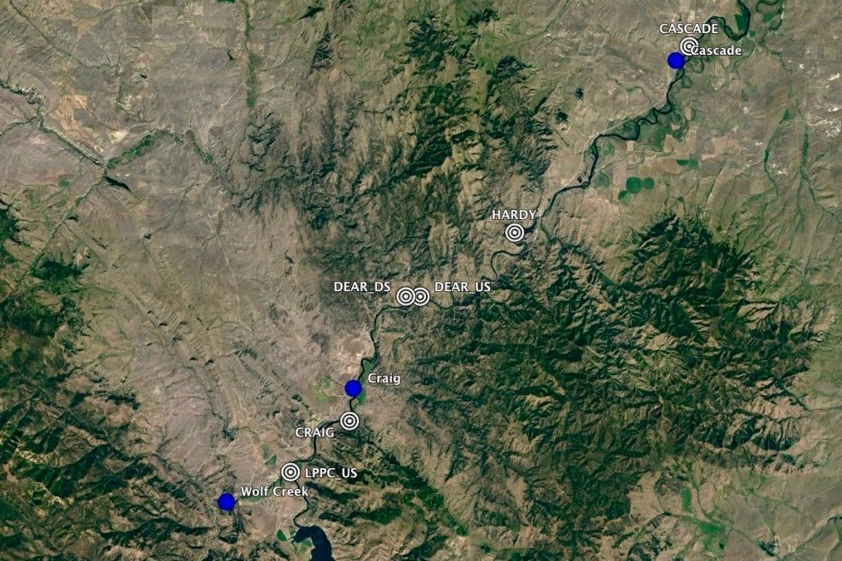
Station ID | Site Name | Latitude | Longitude
MO_LPPC_US | Missouri River U/S Little Prickly Pear | 47.02281 | -112.01527
MO_LPPC_DS | Missouri River D/S Little Prickly Pear | 47.02345 | -112.01523
MO_CRAIG | Missouri River U/S Craig | 47.05415 | -111.96701
MO_DEAR_US | Missouri River U/S Dearborn River | 47.12819 | -111.91174
MO_DEAR_DS | Missouri River D/S Dearborn River | 47.12791 | -111.9109
MO_HARDY | Missouri River U/S Sheep Creek (Hardy Bridge: cover photo) | 47.16781 | -111.83366
MO_CASCADE | Missouri River @ Cascade FAS | 47.28062 | -111.69113

Figure 1. WQ Sampling sites are denoted by bull’s-eyes.

2.2 Sample Timing
Samples were collected seasonally in order to examine temporal changes in water quality through the year, especially related to the summer irrigation/growing season. In 2018, samples were collected in June, July and October. High water during the spring prevented the collection of April samples.

Summer 2018 samples were collected on June 20th, July 24th and October 1st, while in 2019, only a fall sampling period was collected (October 4th) (Figure 1). These samples captured a high-flow event, summer base-flow during the growing season and post-irrigation water quality.

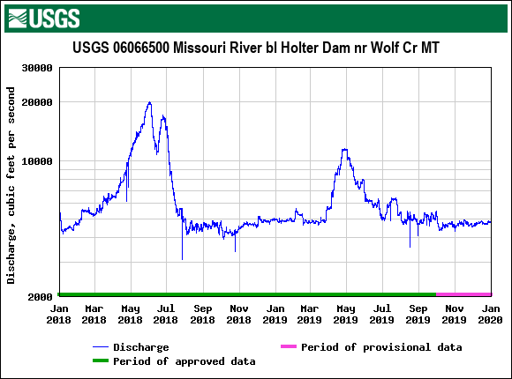
Figure 2. Discharge below Holter Dam from Jan 2018-2020. Red arrows represent sampling dates

2.3 Water Sampling Methods

Water quality samples were collected in sterilized bottles provided by Energy Laboratories Inc. At the time of sample collection, each bottle and lid were triple-rinsed with ambient river water prior to collecting the final sample. Total nitrogen samples were collected in 250 mL HDPE bottles and kept on ice until analyzed. Total phosphorus and inorganic nitrogen (nitrate and nitrite) samples were collected in 250 mL HDPE bottles, preserved with sulfuric acid, and kept on ice until analyzed. Total suspended solids and total dissolved solids samples were collected in 1000 mL HDPE bottles and kept on ice until analyzed. All water samples were submitted to Energy Laboratories Inc. in Helena, MT within 48 hours of collection.

2.4 Quality Assurance – Field Blanks and Duplicates

During each seasonal sampling, one field duplicate and one field blank set of samples were collected to ensure the quality of the sampling procedure and the accuracy of the lab analysis. Field duplicates consist of an extra set of sample bottles filled with the same water from the same sampling site. Field duplicates were collected, handled, and stored in the same way as the routine samples for laboratory shipment. In theory, a duplicate sample should yield results identical to the other sample taken at the same site at the same time. Collecting and analyzing duplicate samples ensures that the sampling and analysis process is consistently accurate.
Field blanks consist of an extra set of sample bottles filled with deionized (DI) water and transported with the other samples in the field. Field blanks were prepared in the field at the same time as the routine samples and handled and analyzed in the same way as the routine samples. In theory, field blank samples should be clean of all contaminants. Collecting and analyzing field blank samples ensures that the sampling and analysis processes are free of contaminants.

2.5 Water Quality Analysis

Energy Laboratories Inc. in Helena, MT analyzed all water quality samples. Energy Laboratories Inc. routinely processes 1,000’s of WQ samples for MDEQ, USEPA and other agencies, and has been proven to provide laboratory data of very high accuracy and consistency.

3.0 Results for 2018 and 2019

Whenever possible, results were interpreted relative to established MDEQ numeric standards within the same ecoregion. MDEQ established these numeric water quality criteria to control limits on pollutant levels in Montana’s wadable rivers and streams. Numeric nutrient criteria have not yet been developed for the Missouri River, although DEQ is currently developing these standards. Circular 12A (MDEQ 2014) provides base numeric nutrient standards of 0.3 mg/L for total nitrogen (TN) concentrations and 0.03 mg/L for total phosphorus (TP) concentrations. The screening value of 0.1 mg/L for inorganic nitrogen concentrations was provided via personal communication with MDEQ staff. Screening values and numeric nutrient standards are represented as horizontal lines on the graphs. A table of all 2016-2019 WQ results is available in Appendix A.

3.1 Total Dissolved Solids

In 2018, Total Dissolved Solid (TDS) concentrations ranged from 166 and 208 mg/L and averaged 188 mg/L across all sites and seasons; no distinct spatial trends were noted, but seasonally, June 2018 samples had the highest levels, summer samples had the lowest TDS, and at sites located below tributaries (MO_LLPC_DS, MO_DEAR_DS), fall reported the highest levels (Figure 3). In 2019, TDS concentrations ranged between 203 and 217 mg/L and averaged 209 mg/L across all sites; again, the highest levels were reported at sites below the major tributaries in the Fall (Figure 3).

Figure 3. Total Dissolved Solid levels across the UMOWA sites in 2018 and 2019.

3.2 Total Suspended Solids
In 2018, Total suspended solids (TSS) concentrations ranged between 0.8 and 10 mg/L and averaged 3.4 mg/ L across all sites and seasons (Figure 4). In 2019, TSS concentrations ranged between 0.8 and 2.0 mg/L and averaged 1.4 mg/ L across all sites in the fall. Not surprisingly, the highest TSS values in 2018 were reported from the samples taken during the high-flow June period (Figure 2 & 4).

Figure 4. Total Suspended Solids (TSS)across the UMOWA sites in 2018 and 2019.

3.3 Inorganic Nitrogen

In 2018, Total Inorganic Nitrogen (NN) concentrations ranged between 0.0 and 0.19 mg/L and averaged 0.09 mg/L across all sites and seasons; this is just below the MDEQ screening value (Figure 5). June 2018 reported 6 sites with NN concentrations above the screening level, and in October had 5 in this range (Figure 5). In Fall 2019, NN concentrations ranged between 0.0 and 0.12 mg/L and averaged 0.08 mg/L: much lower than in the fall of 2018. The highest NN values in 2018/2019 were reported from samples taken during the fall 2018 sampling period and lowest during the summer period, below the Dearborn reported non-detectable levels (Figure 5).

Figure 5. Total Inorganic Nitrogen levels across the UMOWA sites in 2018 and 2019.

3.4 Total Nitrogen

In 2018, Total Nitrogen (TN) concentrations ranged between 0.07 and 0.49 mg/L and averaged 0.35 mg/L (±0.03 SE) across all sites and seasons; this is above the MDEQ nutrient standard for wadable streams (Figure 6). In October 2019, TN concentrations ranged between 0.05 and 0.36 mg/L and averaged 0.25 mg/L across all sites. The spatially highest TN values in 2018/2019 were reported from the samples taken during the high flow June period (Figure 6). Elevated TN concentrations with levels above the MDEQ standard were reported at 6 of the 7 sample sites in June of 2018 and this continued into October of 2018, except for site MO_LPPC_DS (Figure 6). October 2017 was the first sample period of this project where Missouri River samples began exhibiting elevated TN levels (Figure 7).

Figure 6. Total Nitrogen levels across the UMOWA sites in 2018 and 2019.

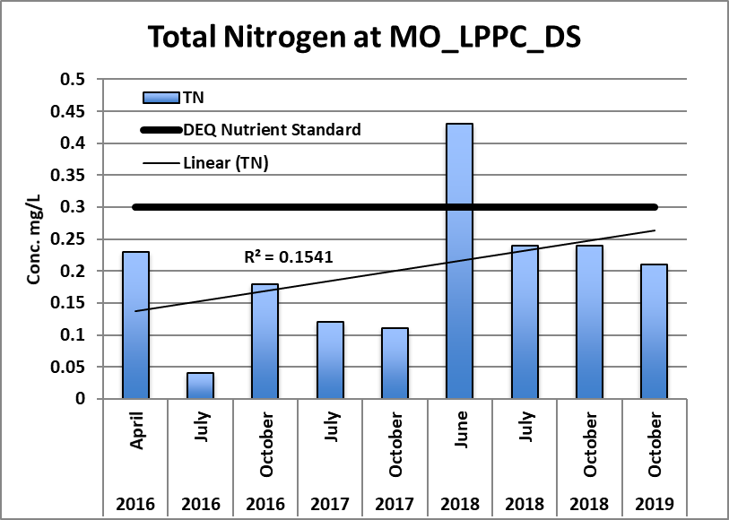
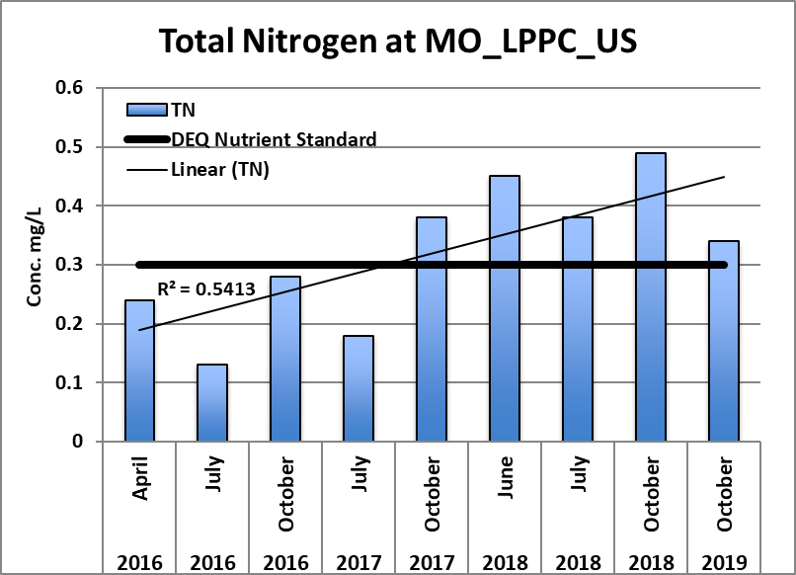
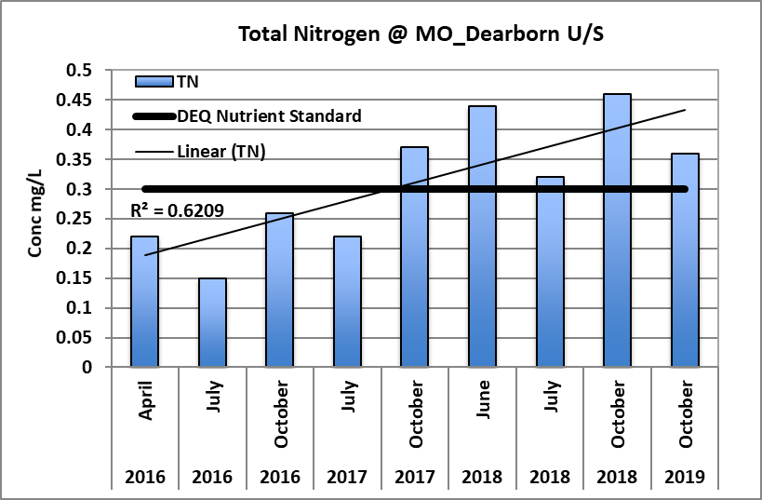
Figure 7. Total Nitrogen levels across the UMOWA sites between 2016 and 2019.
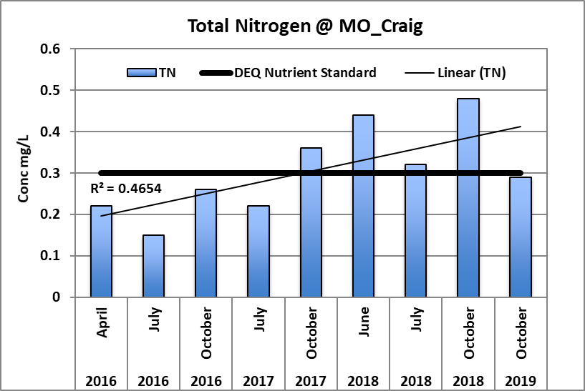
Figure 7. cont. Total Nitrogen levels across the UMOWA sites between 2016 and 2019.
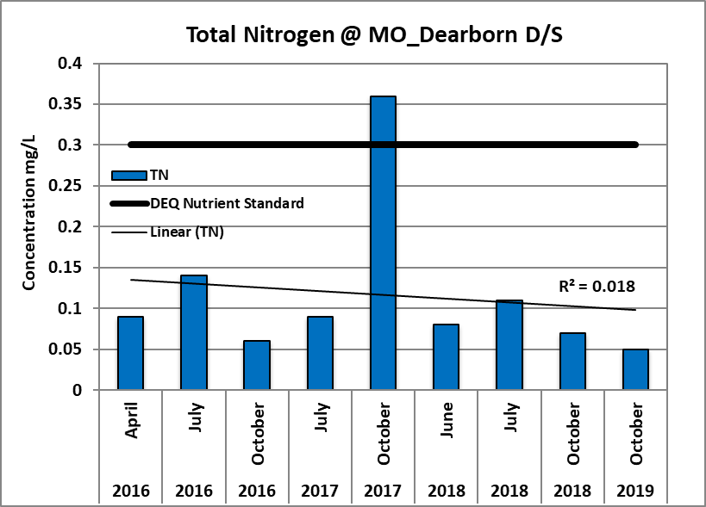

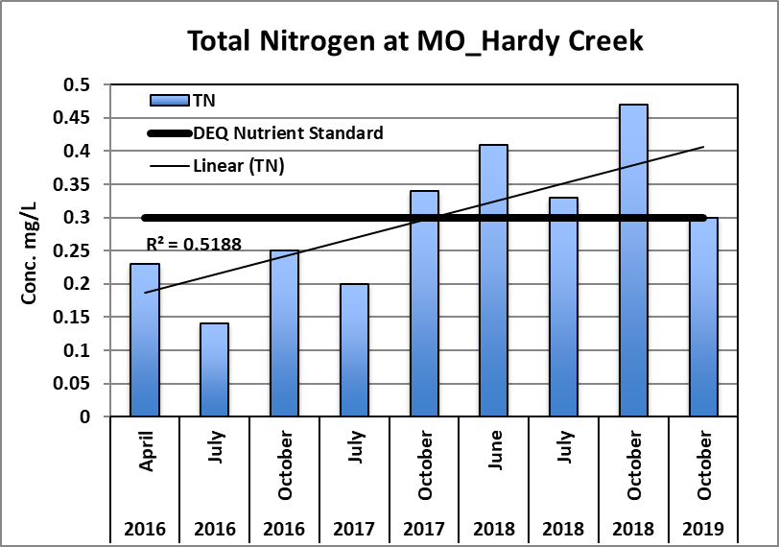

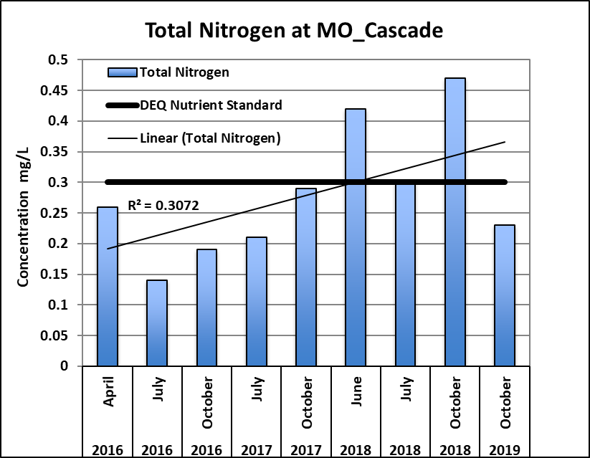

3.5 Total Phosphorus

In 2018, Total phosphorus (TP) concentrations ranged between 0.0 and 0.081 mg/L and averaged 0.037 mg/L (±0.006 SE) across all sites and seasons; 5 of 7 sites were above the MDEQ nutrient standard (Figure 8). These elevated TP concentrations reported in October of 2018 continued into the fall of 2019 with 6 of the 7 sample sites reporting levels above the MDEQ standard (Figure 9).

Figure 8. Total Phosphorus levels across the UMOWA sites in 2018 and 2019.

Figure 9. Total Phosphorus levels across the UMOWA sites in 2019.

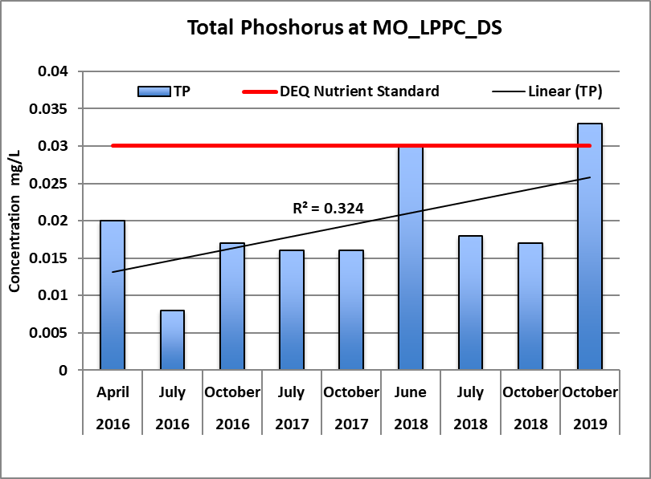
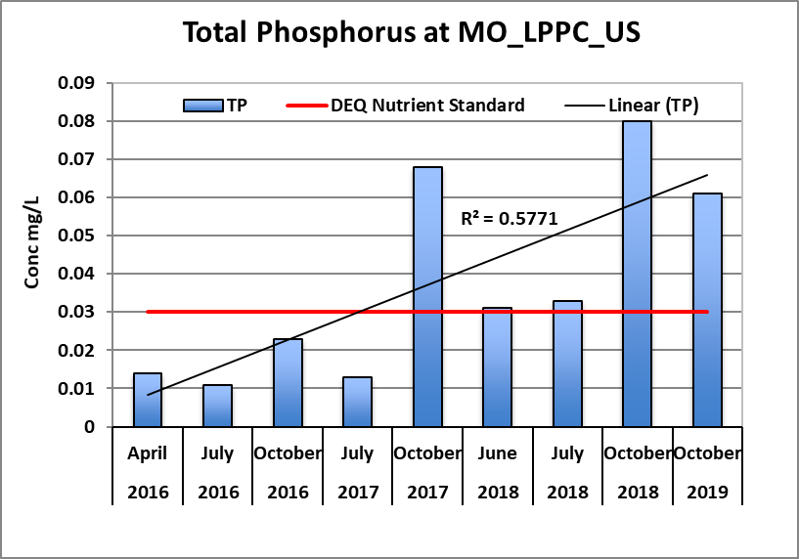
Figure 10. Total Phosphorus levels across the UMOWA sites between 2016 and 2019.
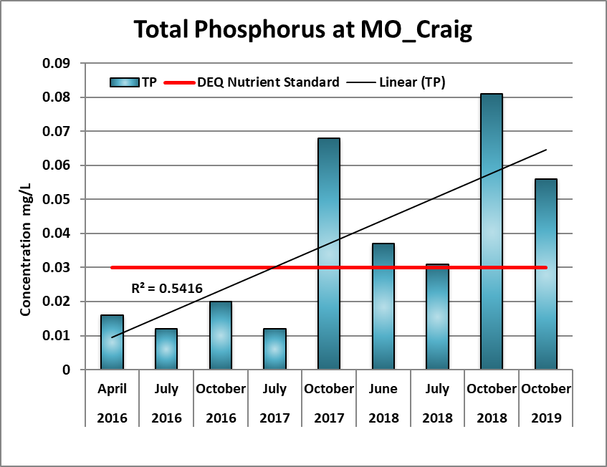

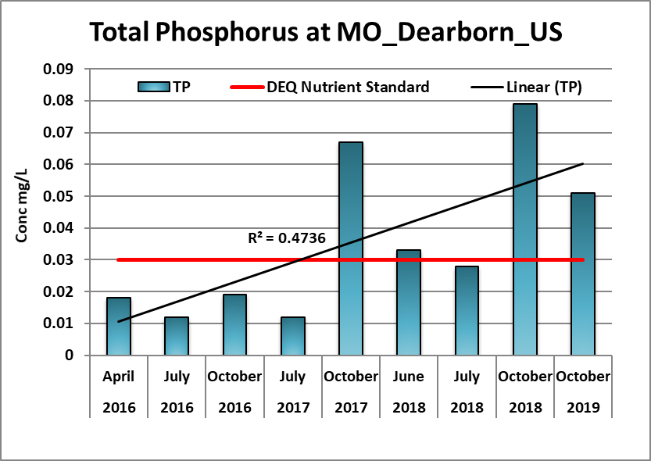

Figure 10. cont. Total Phosphorus levels across UMOWA sites between 2016 and 2019
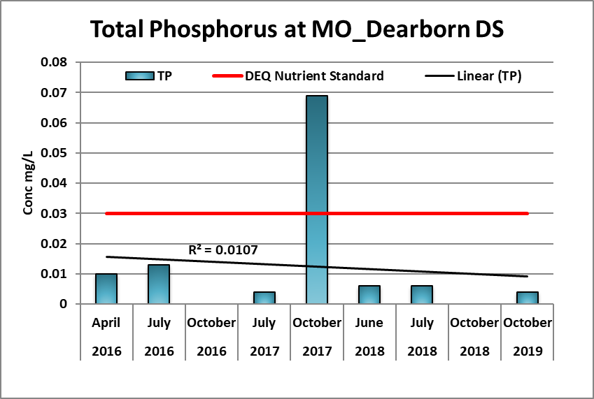
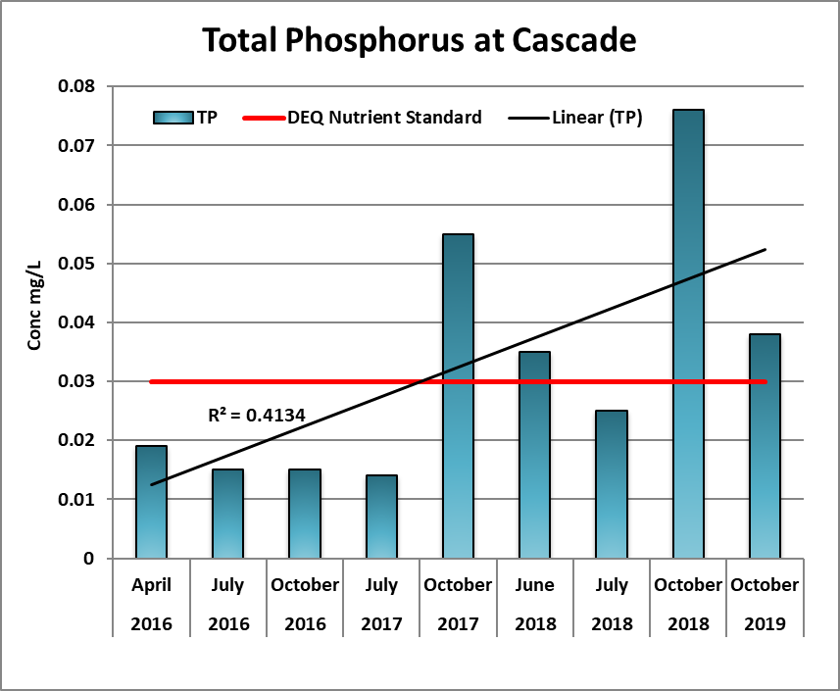
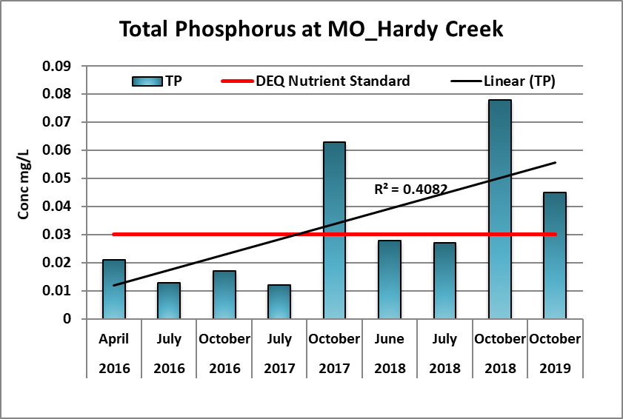

4.0 Discussion

4.1 Spatial Trends

When comparing Missouri River upstream sites closer to Holter Dam to downstream sites, no strong trends were observed for any of the measured parameters in 2018, except below the tributaries. When nutrients were exceeding the DEQ nutrient thresholds, they are elevated from upstream of Little Prickly Pear Creek all the way down to Cascade, usually at close to the same concentration level (Figure 6 & 8). There were no documented “big spikes or dips” between sites unless a tributary comes in an dilutes levels down for a kilometer of 2km until full mixing occurs, then nutrient levels go right back up. There were a couple of notable exceptions; the Missouri River samples taken below Little Prickly Pear Creek and the Dearborn River reported reduced nutrient levels below MDEQ nutrient standards in all seasons, except June 2018. During October 2018, the MO_DEAR_DS site yielded very low TP (non-detectable) concentrations (Figure 10). In October 2019, a slight declining trend in TP concentrations was noted between the u/s sites to d/s (Figure 9). Concentrations of all three nutrient parameters (NN, TN and TP) were much lower at the MO_DEAR_DS site than elsewhere during the same time period. This strongly suggests that the Dearborn River discharge is creating a localized reduction in nutrient levels downstream of its confluence during all seasons (Figure 6 & 8).

4.2 Seasonal Trends

Total dissolved solids (TDS) concentrations were higher in June than in October for five of the seven sites in 2018. The elevated concentration of TDS observed during high flows of June 2018 is anomalous, TDS levels are usually lower during run-off due to dilution effects and then higher during the summer months as flows are reduced. TDS values measured with a hand-held Oakton meter during June high flows of 2017 of 2017 ranged from 150-165 mg/L (Stagliano 2017, Appendix D) much lower than what was being reported for June 2018. It is unclear as to what extent natural and anthropogenic sources (fertilizers, pesticides, etc.) are contributing to elevated TDS concentrations during the June run-off period (Total Nitrogen is also very elevated during this period). But, high readings of TDS were also reported at all sites in Fall of 2019, especially below the tributaries.
Overall, nutrient levels were greater in October than June or July in 2018; TP was significantly higher in Oct. than June (T-test, p=0.04) or July (T-test, p=0.025). Inorganic nitrogen, total nitrogen, and total phosphorus concentrations increased between July and October for six of the seven sites (the one exception was the MO_DEAR_DS as described in 4.1).

4.3 Yearly Trends

Total dissolved solids (TDS) concentrations were consistently higher in 2018 and 2019 than reported in 2016 or 2017, although, this parameter was inconsistently sampled, so yearly comparisons may be unreliable (Appendix A). TSS concentrations reached their highest levels in April 2016 and June 2018, but then were similar between Fall 2018 and 2019. TSS concentrations were zero (not detected) at all sites between July 2016 and October 2017, except at the Cascade site, which exhibited moderate concentrations during July of all years (Figure 11). TSS concentrations may be correlated with or a contributor to higher nutrient levels.

Figure 11. Total Suspended Solids (TSS)across the UMOWA sites from 2016 to 2019.

5.0 Conclusions

This study has established a comprehensive baseline of the water quality in the upper Missouri River over four very different water years (2016-2019) and has elucidated several spatial and temporal trends. The overwhelming trend observed between 2016 and 2019 is a substantial increase in inorganic nitrogen (NN), total nitrogen (TN), and total phosphorus (TP) concentrations in the Missouri River to levels exceeding MDEQ nutrient standards since October of 2017. Nutrient exceedances were reported from the furthest upstream site all the way down to Cascade, except at sites below the tributaries, Little Prickly Pear Creek and the Dearborn River where somewhat insulated from these increasing nutrient trends, but some seasonal increases are being documented.

During October of 2017, 5 of 7 sites exceeded the MDEQ recommended screening and nutrient standard values for NN and TN concentrations, respectively, and 6 of 7 sites exceeded the nutrient standard for TP concentrations. Since the initiation of this study in April 2016, these were the first observed instances of nutrient concentrations exceeding the MDEQ nutrient standards and screening values, and most sites have been in exceedance of the thresholds since then, especially in the Fall of 2018 and 2019.

These continued increases in the Upper Missouri River nutrient levels to concentrations exceeding the recommended levels set by MDEQ is a significant cause for concern. High nutrient levels causally related to the excessive aquatic plant and algae growth are the biggest threats that the Upper Missouri River is currently facing. It is critical that UMOWA continue to monitor water quality parameters in 2020 to see if these nutrient concentrations remain at impaired levels. Additional upstream watershed BMP measures (riparian vegetation buffers, cattle fencing, etc.) should be evaluated to alleviate non-point source nutrient additions to the ecosystem.

6.0 References

Appendix A: Impaired Waters. (2016). Available at: http://deq.mt.gov/Portals/Impaired Waters2016

Montana DEQ 2014. Planning Prevention and Assistance Division, Water Quality Planning Bureau, Water Quality Standards Section. 2014. DEQ Circular-12A Montana Base Numeric Nutrient Standards. Helena, MT: Montana Dept. of Environmental Quality.

Stagliano, D. 2015. UMOWA Baseline Macroinvertebrate Monitoring Report 2015 for the Upper Missouri River, MT. Report to the Upper Missouri River Alliance.

Stagliano, D. 2017. UMOWA Baseline Summary Macroinvertebrate Monitoring Report for 2015-2017 for the Upper Missouri River, MT. Report to the Upper Missouri River Alliance.

UMOWA. 2018. Baseline Water Quality Report 2016 and 2017 for the Upper Missouri River, MT. Report to the Upper Missouri River Alliance.

APPENDIX A. WATER QUALITY RAW DATA FROM 2016-2019

