Nutrient Trends Slightly ‘Better’ during the 2020 Missouri River Water Quality Study
Dave Stagliano, Montana Biological Survey
UMOWA has been out collecting water chemistry (WQ) samples on the Missouri River again in 2020 (5th year) at 7 sites from Wolf Creek to Cascade. We have collected rigorous data on Total Dissolved Solids (TDS), Total Suspended Solids (TSS) and nutrients (Nitrogen {TN} and Phosphorous {TP}) during a variety of river conditions, from low discharge years (2016) to one of the highest (2018) recorded in 20 years. WQ Samples are collected seasonally in May, July and October to coincide with irrigation seasons.
Spring and Summer TN and TP levels in the Missouri were relatively low in 2020 as the river volume was large (dilution) and aquatic plant growth was in full swing (taking nutrients from the water column). During the fall (low flows and slow plant growth), TN concentrations upstream of Little Prickly Pear Creek and TP levels at 4 of our 7 sites on the Missouri exceeded the recommended levels set by MDEQ (Figures 1 & 2). This has been the pattern since the initiation of this study in April 2016, in fall of 2017 and every fall since, nutrient concentrations (TN and TP) have exceeded the MDEQ nutrient standards across most sites (Figure 3).

Figure 1. Total Nitrogen levels across the UMOWA sites in 2020.
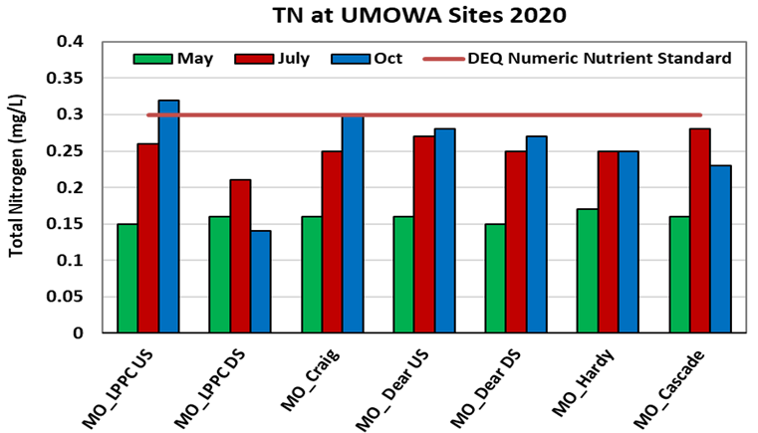

Figure 2. Total Phosphorus levels across the UMOWA sites in 2020.
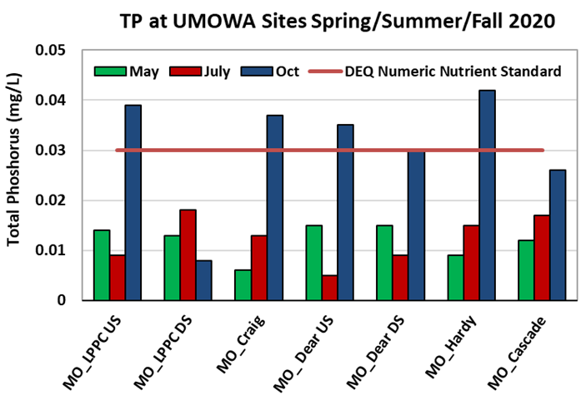

Figure 3. Total Phosphorus levels at the UMOWA site near Craig from 2016 to 2020.
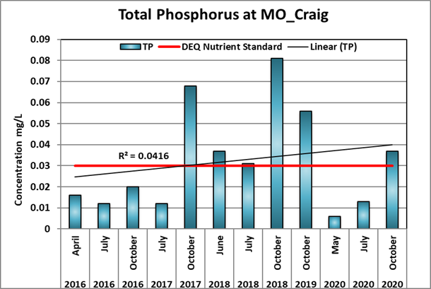

So, although the Missouri River nutrient levels exceeded the recommended levels this fall, they are not as high as they have been in previous years (Figure 3). Phosphorus is the limiting nutrient for plant growth in the Missouri--the more you add, the more plant growth will occur. It is critical that UMOWA continue to monitor WQ parameters in 2021 to track nutrient concentrations and evaluate upstream watershed management actions (i.e., riparian vegetation buffers, cattle fencing) that may keep sediment and nutrients out of the Missouri River.

