Upper Missouri River Water Quality Report 2024: Sneak Peek
Total Nitrogen reported seasonally in 2024, exceedances of the old DEQ standard again reported in Fall across most sites except at MO upstream of Little Prickly Pear Creek in July and September, no Fall sample taken at Townsend.
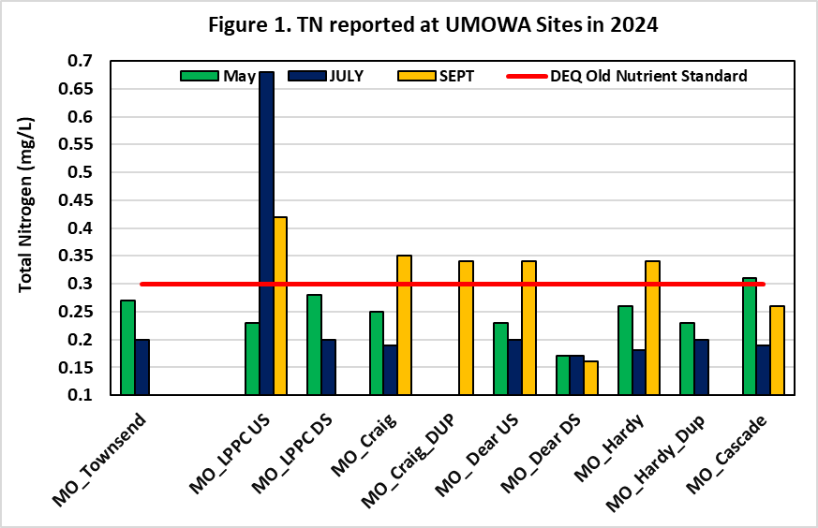

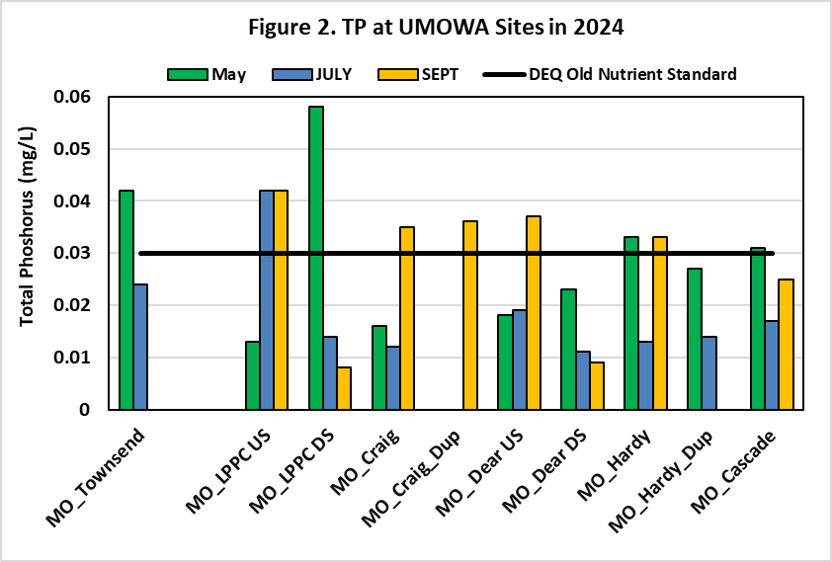
Total Phosphorus reported seasonally in 2024, exceedances of the old DEQ standard again reported in the Fall across most sites, except Spring at MO Townsend and downstream of Little Prickly Pear Creek. High TP values at MO_LPPC US were reported in both Summer and Fall, but other sites’ summer TP values were much lower, kinda weird!!

