UMOWA Weed Management Program for Bluebird Drive
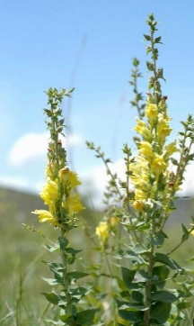
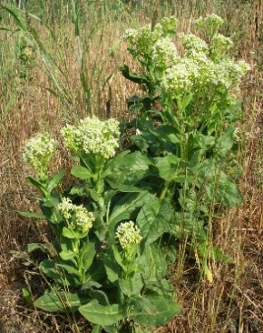
Target Weeds:
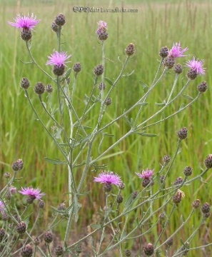
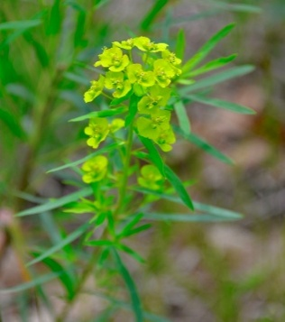

Leaf Spurge Spotted Knapweed Dalmatian toadflax Whitetop

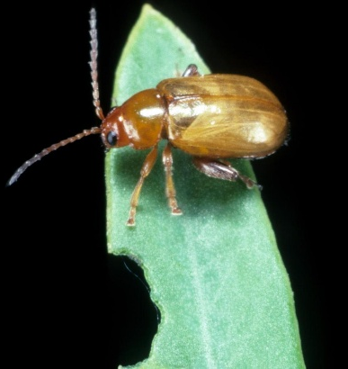
Host Specific Biological Control Agents for Leafy Spurge Suppression 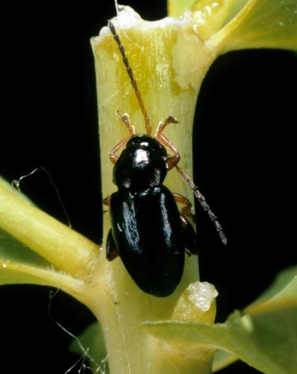
Leafy spurge flea beetles (black, brown, or copper) (Aphthona species) are small,1-6 mm long, and only attack leafy spurge. Adult flea beetles feed on leafy spurge leaves and flowers from late spring through summer and lay eggs in soil at base of leafy spurge plants. The Aphthona eggs hatch into larvae that eat root hairs and young roots, inhibiting root function and stunting spurge growth. At some locations larval feeding makes attacked roots more susceptible to soil-inhabiting pathogens.
Aphthona lacertosa Aphthona nigriscutus
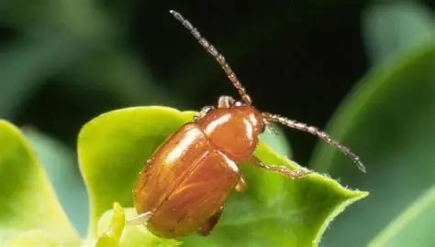

Aphthona flava
Red-headed leafy spurge stem borers (Oberea erythrocephala) (left) only attack leafy spurge. Adults are 10-12 mm long, emerge in early to mid-summer and feed on leafy spurge leaves and flowers. Females girdle a leafy spurge stem, chew a hole, and lay a single egg which hatches into a larva that mines down the stem until reaching the root crown and lateral roots. Larval mining kills shoots and reduces root reserves; adult female girdling of stems often leads to shoot death reducing seed production.
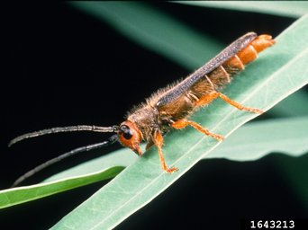

Herbicides for Leafy Spurge Management
UMOWA uses a combination of Tordon 22K (active ingredient picloram, EPA Reg # 62719-6) and Platoon (active ingredient 2,4-D, EPA Reg # 228-145) to treat target weeds along roadsides. This herbicide mix kills leafy spurge and other broadleaf plants but does not kill grasses. Herbicide treatment along roadsides reduces existing weed populations and prevents weed spread to new areas by vehicles.
Revegetation- A Vital Components of Successful Long-Term Weed Management
As target weed populations are reduced, revegetation introduces desirable plants to fill the spaces target weeds used to dominate. The field seed mix developed for UMOWA is made up of native grasses: Mountain brome, Sandberg’s bluegrass, Bluebunch wheatgrass, Idaho fescue, Blue wildrye, Great basin wildrye; and Sterile wheatgrass to compete with aggressive weedy annual grasses, including cheatgrass, until desired native grasses and forbs get established.
Additional Resources
The North American Invasive Species Management Association hosts a series of fact sheets about invasive plants (including the Birdseye Road target weeds identified above) and host specific weed biological control agents. In your search engine type “NAISMA Biocontrol Resources” or https://naisma.org/programs/biocontrol-resources/?e-page-e478aac=3
For more information about the herbicides used in UMOWA’s program, please refer to the EPA Pesticide Labels for Tordon 22K (EPA Reg # 62719-6) and Platoon (EPA Reg # 228-145).
For more information about Upper Missouri Watershed Alliance (UMOWA), please visit their website at https://umowa.org/

