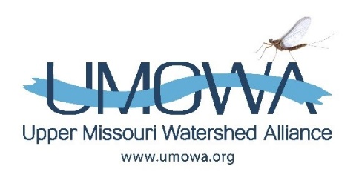
Upper Missouri Watershed Alliance (UMOWA) is a non-profit organization created to understand, conserve, and enhance the unique ecological and recreational resources of the upper Missouri River. UMOWA is guided by a volunteer board of directors with non-voting members and relies on private donations and grants for projects and operations. We collaborate with State and local agencies, other non-profits, and business entities to protect the watershed’s resources.
Our focus has been the Missouri River and its tributaries between Holter Dam and Ulm. Our work includes collecting and analyzing scientific data to set a base-line and establish trends over time so that we can mitigate short and long-term negative impacts on the watershed. We are also involved in bank restoration projects and efforts to reduce current invasive plant and animal populations and prevent new introductions. Through our website (UMOWA.org) and newsletters, we seek to educate landowners and recreational users of the Missouri about our efforts and how they can help to protect river health.
Membership/Outreach Coordinator
UMOWA is seeking a dynamic and self-motivated individual to increase membership and financial support and to engage current members in our volunteer and educational opportunities. The successful applicant will, with heart and passion, communicate the value of our work with the community at large, and lead and support our board of directors in implementing successful fundraising strategies.

Primary Responsibilities
- Develop and implement a communications plan. Manage the marketing and engagement tools needed to implement the plan.
- Create, produce and distribute printed and on-line materials to support messaging strategy.
- Work with Board Chair to keep website up-to-date and relevant.
- Assist with publication of hard-copy newsletter.
- Manage UMOWA’s donor database.
- Assist UMOWA board in developing a successful fundraising plan based on past and projected donor patterns and new research.

Preferred Skills/Abilities
- Strong storyteller – excellent written and verbal communication skills
- Organized and self-motivated
- Flexible, responsive, and able to manage diverse priorities
- Experience developing and delivering communications strategies, using multiple platforms
- Proficiency in Microsoft Office, google applications, and donor database programs
- Experience with nonprofit organization fundraising
- Knowledge of the Upper Missouri River community a plus

Independent Contractor Position
$20/hour, 15 hours per week. Includes occasional evenings and weekends. Requires the use of your own personal vehicle (mileage reimbursed), cell phone and computer. One-year contract length with Board review every 2 months to assess performance and refocus/retool as necessary based on established metrics.

How to Apply
Send your resume with a cover letter telling us what you find interesting or challenging about this position to smeador@umowa.org. Position will be open until filled.

